**Lab 1.3**

Sơ đồ class:

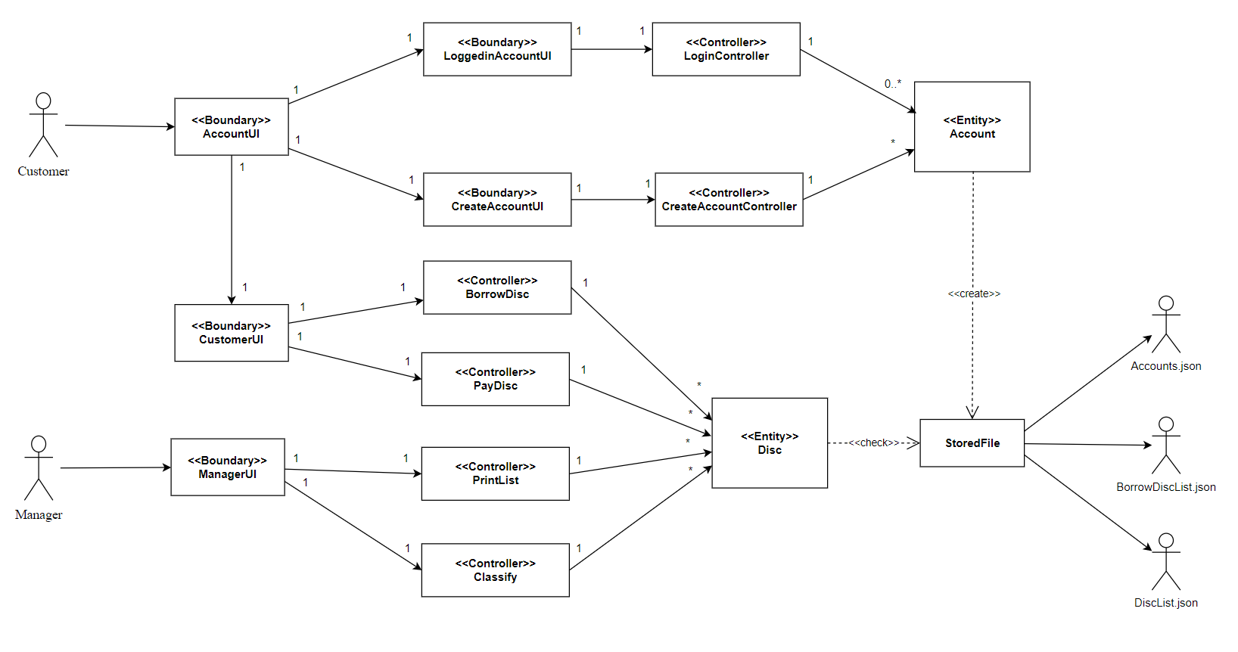

Sequence Diagram:

